**Ideation Phase**

**Define the Problem Statements**

|  |  |
| --- | --- |
| Date | 26.06.2025 |
| Team ID | SWUID20240036329 |
| Project Name | Ora Social Media App |
| Maximum Marks | 2 Marks |

**Customer Problem Statement Template:**

To define the core problems users, face on mainstream social media platforms, and use those insights to guide the development of a community-based social media app.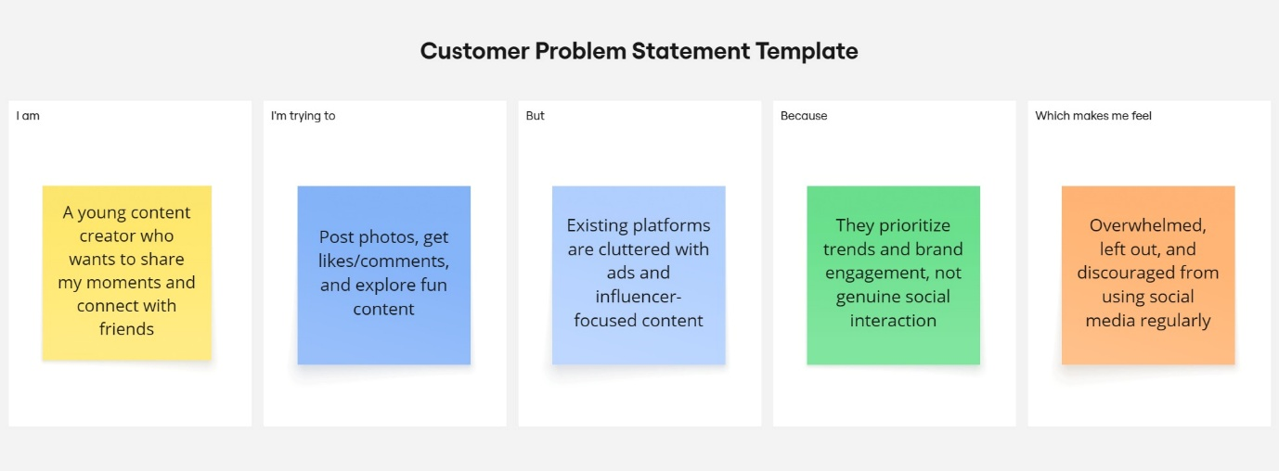

Reference: <https://miro.com/templates/customer-problem-statement/>

|  |  |  |  |  |  |
| --- | --- | --- | --- | --- | --- |
| **Problem Statement (PS)** | **I am (Customer)** | **I’m trying to** | **But** | **Because** | **Which makes me feel** |
| PS-1 | A young content creator looking for a fun, simple way to share posts and connect with others. | Share photos and thoughts, get likes/comments, and see what others are doing. | Popular platforms are filled with ads, complicated features, and privacy concerns. | They are built for mass marketing and influencer culture, not casual users. | Left out, overwhelmed, and hesitant to share anything personal. |
| PS-2 | A student who wants to build a community around shared interests. | Post freely, engage in comments, and explore other posts easily. | Most platforms push irrelevant content and lack personal interaction. | Algorithms prioritize trends and influencers over friends or local users. | Disconnected from my friends and less motivated to post. |